ORIGINAL

Analysis of 16S rRNA genes to characterize microbial community structure in marine sediments from wastewater-treatment discharge fields

Mar Pollution Bulletin

Authors: Stephanie D. Friedman ^{a *}, Katelyn Houghton ^{a ,b} and Marcus W. Beck ^{c}

Author affiliations:

ª US Environmental Protection Agency, 1 Sabine Island Drive, Gulf Breeze, FL, 32561, USA

^{c} Southern California Coastal Water Research Project (SCCWRP), 3535 Harbor Boulevard, Suite 110, Costa Mesa, CA, 92626, USA.

Corresponding author: * friedman.stephanie@epa.gov

^{b} Katelyn Houghton oim2@cdc.gov

^{c} Marcus W. Beck marcusb@sccwrp.org

Current affiliation:
^{b} Division of Parasitic Diseases and Malaria, Center for Global Health, Centers for Disease Control and Prevention, 1600 Clifton Rd, Atlanta, GA, 30329, USA

WE HAVE TO DEPOSIT THESE IN NCBI AND GET ACCESSION NUMBERS; KATELYN

Abstract (150 word max, has 150)

Some of the nation’s largest wastewater-treatment plants are in southern California. Treated sewage is discharged offshore into the Pacific Ocean through a network of outfalls, yet little is known on the potential effects on microbial communities in the sediment. 16S rRNA genes were sequenced from sediment samples to explore the use of these data to evaluate community structure along sewage outfall gradients (close to far) and between outfall sources. Community composition was more similar across locations as distance increased from the outfall pipe, whereas communities closer to outfall pipes had high diversity and low similarity between locations. Firmicutes was the predominant bacteria phylum at most of the stations, whereas Proteobacteria and Actinobacteria dominated the site closest to the Orange County outflow. Overall, this analysis demonstrates how next generation sequencing can be used to evaluate wastewater effects on microbial communities in marine sediments.

Keywords
16S rRNA gene; Microbial communities; Wastewater treatment; Sediments

1. Introduction

Marine and estuarine microbes are critical to the natural environment and robust methods are needed to assess community changes in response to anthropogenic pressures. Bacteria and archaea play a major role in biogeochemical transformation and nutrient cycling processes that are necessary to sustain the health of freshwaters, estuaries, and oceanic ecosystems. In the Los Angeles metropolitan area (California, USA), treated sewage is discharged approximately 5-7 miles offshore into the Pacific Ocean through a network of outfalls. These outfalls originate from wastewater-treatment plants that serve as many as 20 million people, presenting a novel opportunity to evaluate community response to effluent exposure. Little is known about the influence of wastewater effluent on microbial communities harbored within the sediment of effluent outfall. Not only are bacteria and viruses potentially discharged in treated effluent, but nutrients, sand, grit and organic materials can occur in watershed runoff, having potential effects on the physical and biochemical processes that occur within marine sediments (Wakelin et al., 2008).

Genetic sampling methods could be used to evaluate the potential effects of effluent exposure on microbial community structure on marine sediments. Sequencing the 16S rRNA gene is a rapid and feasible approach to characterize microbial communities (Sogin et al., 2006). The highly conserved 16S rRNA gene in bacteria and archaea has sufficient variability to distinguish the taxonomic composition to the individual species or to the Operational Taxonomic Units (OTUs). The OTU is a means to characterize the 16S rRNA gene sequence based on sequence similarity (Stackebrandt and Goebel, 1994). To evaluate the potential effects of wastewater effluent on the microbial community structure, DNA was extracted and sequenced from sediment collected along the outfall gradient from the following four municipalities; Los Angeles County (Joint Water Pollution Control Plant), City of Los Angeles (Hyperion Plant), City of San Diego and from Orange County. The research objective was to survey microbial communities and to identify key microbial taxa or shifts in the taxa that attributed to community variation and/or community uniqueness among and within the wastewater- treatment discharge fields. Changes in community structure related to distance from the wastewater-treatment outflows were also evaluated. This information is expected to provide a baseline assessment of how community response to wastewater effluent can be assessed using genetic sampling methods.

2. Materials and methods

2.1 Sediment collection

As part of an on-going monitoring program coordinated by the Southern California Coastal Water Research Project (SCCWRP, http://www.sccwrp.org/ResearchAreas/RegionalMonitoring.aspx), 14 sediment samples were collected along outfall pipe gradients from four southern California wastewater-treatment discharge fields as follows: i) Los Angeles County, ii) City of Los Angeles, iii) San Diego, and iv) Orange County (Fig 1; Table 1). At each station, two replicate cores were taken from a Van Veen grab. Core tubes were used to extract 5 cm of sediment from the grab. Samples were placed in a 1-quart bag in a cooler with dry ice and transferred to – 80 º C freezer until processed.

Table 1. Site locations for sediment collection. Each station was grouped by nearest governing municipality and further grouped by relative location from the outflow pipe of the nearest wastewater-treatment plant.

Fig 1. Sediment sample stations from the wastewater-treatment discharge fields along the southern California coast. Stations are diagramed by their respective municipality. See Table 1 for a description of each station. Text designations at each site indicate relative categories for distance from each outflow pipe (C = close, I₁, I₂ = intermediate, F = far).

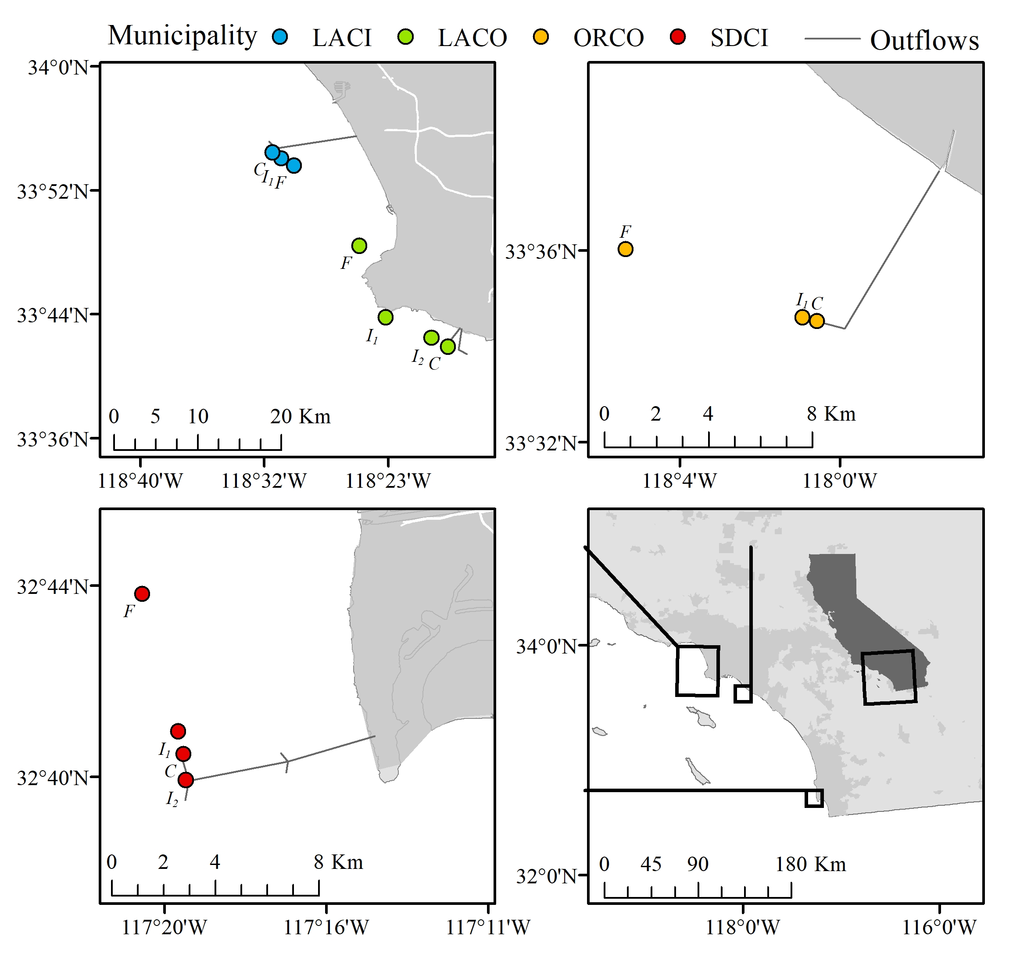

2.2 DNA extraction, PCR and sequencing

DNA was extracted from each sediment sample using a PowerSoil® DNA Isolation kit (Mo Bio Laboratories, Carlsbad, CA) and subsequently cleaned with a DNA Clean and Concentrator kit (Zymo Research, Irvine, CA). All DNA samples were sent to Argonne National Laboratory for Mi-Seq (Illumina, San Diego, CA) paired-end 250 bp sequencing of the 16S rRNA gene. The selected primers targeted the V4 region of the 16S rRNA gene to detect both Bacteria and Archaea (Caporaso et al., and Apprill et al., 2015, , Fouhy et al., 2016). To minimize amplification and sequencing bias, primers used were modified and barcoded for Illumina Mi-Seq platorm as follows. The forward primer 515fB was constructed by i) 5’ Illumina adapter, ii) GoLay barcode iii) forward primer pad, iv) forward primer linker and v) forward primer (515fB) with the following sequence:
5’ AATGATACGGCGACCACCGAGATCTACACGCT XXXXXXXXXXXX TATGGTAATT GT GTGYCAGCMGCCGCGGTAA 3’
The reverser primer 806rB was modified by i) reverse compliment of 3’ Illumina adapter, ii) reverse primer pad iii) reverse primer linker and iv) reverse primer (806rB) resulting in the following sequence:
5’ CAAGCAGAAGACGGCATACGAGAT AGTCAGTCAG CC GGACTACNVGGGTWTCTAAT 3’

2.3 DNA Sequence Analysis

The resulting 16S rRNA sequences were processed using mothur version 1.39.5 (Schloss et al., 2016) following the mothur MiSeq protocol (accessed 6/12/17). Contigs were assembled using the forward and reverse sequences. Sequences were aligned to and classified with the Silva database v128 and any sequences not aligning to the desired region were screened and removed. Any sequences classified as Chloroplast, Mitochondria, unknown, or Eukaryota were also removed. Chimeras were removed using uchime by Robert C. Edgar (http;//drive5.com/uchime). Sequences were clustered into Operational Taxonomic Units (OTUs) based on 97% nucleotide sequence identity. Each sample was sub-sampled to normalize the data and account for differences in sampling effort between samples. Error rates for each sequence run were assessed using the BEI Mock Community B BEI HM-277D. This reagent was obtained through BEI Resources, NIAID, NIH as part of the Human Microbiome Project (Genomic DNA from Microbial Mock Community B (Staggered, High Concentration), v5.2H, for Whole Genome Shotgun Sequencing; BEI Resources, Manassas, VA).

2.4 Statistical analyses

Multivariate analysis. The statistical analyses were conducted to evaluate community differences related to location (each of four wastewater outfalls) and distance from the outfall pipe at each location. The abundance and taxonomy data at the OTU level were analyzed using the multivariate statistics package, Primer v7 (Primer-E, UK). Data were first log(x+1) transformed to down weight the contributions of the most dominant taxa and Bray-Curtis similarity values were calculated from the transformed data. Analysis of Similarity Statistics (ANOSIM, a non-parametric permutation test) on the similarity values was run to test the effects of location and position from the outfall. OTU level non-metric multidimensional scaling was based on the Bray-Curtis dissimilarity matrix of abundance data. SIMPER analysis (similarity percentages) was used on the OTU level data to determine species contributions to within-group similarity. SIMPER calculates the contribution of each OTU to the Bray-Curtis similarity of a specified group.

Analysis of diversity. Alpha diversity (Fisher et al., 1943) was estimated at the genus level for each sampling station/site. Differences in diversity between sites were evaluated using a simple analysis of variance (ANOVA) to test for a main effect of distance from the wastewater outflow pipes or by municipality. Diversity estimates were grouped by distance categories across municipalities for the first analysis. Similarly, diversity estimates were grouped by municipality across the distance categories for the second analysis. Assumptions for ANOVA were verified using Bartlett’s test of equal variances between groups with the diversity data and Shapiro-Wilk test of normality of the residuals from the model output (R Core Team, 2017).

3. Results

3.1 Microbial communities

16S rRNA gene analysis. A total of 14 sediment samples were collected. The sequenced DNA from the samples resulted in 1,095,155 contigs assembled using the forward and reserve reads, with an average sequence length of 254 bp. OTUs based on 97% nucleotide sequence identity resulted in a total of 564,711 sequences. Each sample was sub-sampled to 27,499 sequences/sample. The sequencing error rate was determined as 0.00013971 (0.01%) using the BEI Mock Community.

Abundant taxa. Phylum Firmicutes was the dominant bacteria (39.4-70%) across all municipalities and distance categories from the outfall pipes (Supplement X). An exception was observed at the Orange County “close” location that was dominated by the phyla Proteobacteria (34.6%), Planctomycetes (12%), Actinobacteria, (11.9%), Bacteroidetes (11.6%), Chloroflexi (8.6%) and Firmicutes (7%). Proteobacteria was the second most abundant phylum ranging from 34.6% (ORCO_{c}) to 14% (LACI_{f}) across all stations. Planctomycetes was the third most abundant phylum ranging from 3-8%, in all municipalities/stations except for ORCO_{c} (12%). Bacteroidetes ranged from 2-4% in all stations/municipalities except for ORCO_{c (}11.6%) (FIG 2; Supplement X).
For genera, Peptostreptococaecea was often the most abundant genus ranging from 29-2.6% across all stations except ORCO_{c} (0.18%), followed by Bacillaceae (25-4%), again, with the exception of ORCOc (2.89%). All genera in ORCO_{c} were generally not abundant compared to the other stations, with the most abundant being OM1_clade_ge (7.7%), Pir4_lineage (5.8%), Desulfobulbaceae (4.2%) and the remaining approximately top 20 abundant genera being around 2% or less. OM1_clade_ge was 7.7 and 3.6%, respectively, at the two ORCO stations (close and intermediate1) and was approximately 2% or less at the remaining 12 stations. Overall, Peptostreptococaecea was the dominant genus at three stations (29-16%), Bacillaceae was dominant at four stations (25-13%), and Clostrididiaceae (17-4%) was abundant at 10 stations. Tepidibacter was abundant (21-4.7%) at 10 out of the 14 stations (Supplement X).

3.2 Statistical analyses

Multivariate analysis. A non-metric multidimensional scaling plot (nMDS) based on the Bray-Curtis dissimilarity matrix of abundance at the OTU level is illustrated in Figure 3. Samples are keyed based on municipality with lines joining the distance categories from the outfall pipe. These results demonstrate that samples farthest from the pipe are more similar in community structure between municipalities (site groupings toward the center of the plot), whereas samples closer to the pipe are more different (more separation, removed from the plot origin). The response is somewhat variable depending upon the wastewater municipality, however, the overall trend is the same.

The two-way nested ANOSIM (Table 3) highlights and supports the trends demonstrated in the MDS plot (Fig 3). The test for diversity differences between municipality was statistically significant (p < 0.002) with an overall R value of 0.43. An R value equal to 1 would suggest the locations were completely different in community structure, whereas an R value of 0 would suggest no distinguishable difference between groups. Results comparing diversity between distance categories independent of municipality had R=0.542 (p < 0.064) (Table 3), suggesting community structure also varied by distance (close, intermediate, far) to the outflow.

SIMPER analysis showed that communities within groups “close” to the pipe were least similar, while the “farthest” samples from the outfall were most similar (Table 2). These similarity measures reflect the same trends observed in Figure 3 and Table 4.

Table 2. Similarity of each “distance from the outfall pipe” group as determined by the SIMPER statistical analyses.

Group Average Similarity Within Group
Close 40.87
Intermediate 44.71
Far 48.98

Analysis of diversity. Diversity was highest closest to the outfall pipes and declined with increasing distance independent of municipality (Table 3, F = 8.6, df = 2, 11, p < 0.01). Post-hoc comparisons suggested that the “far” stations were significantly different from the “intermediate” and “close” stations (p<0.01; Table 3). Over half (adjusted R² of 54%) of the variation in diversity was explained by distance from the outfall pipes. These tests support the multivariate findings that microbial communities farthest from the outfall pipes were different than the sample stations closest to the pipes. Diversity at each site/station was not significantly different between municipalities independent of distance from the outfall pipes.

Fig 2. Top ten phyla based on wastewater-treatment plant (municipality) and distance from the outfall pipe as determined by percent abundance.

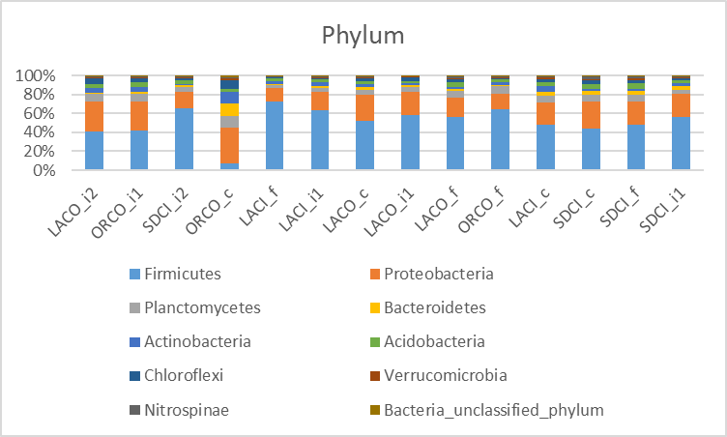
Table 3. Summary of analysis of variance results for community diversity with distance from outfall pipe. Diversity measures were based on Fisher’s Alpha (Fisher et al., 1943) using abundance of genera at each site. The model intercept is the average diversity estimate (standard error in parentheses) at all close sites and the remaining parameter estimates (intermediate and farthest) are referenced accordingly.

 | Microbial Community
 | Models
Constant (close) | 88.68∗∗∗
 | (3.88)
Intermediate | −14.72∗∗
 | (5.01)
Farthest | −22.30∗∗∗
 | (5.48)
Observations | 14
R² | 0.61
Adjusted R² | 0.54
Residual Std. Error (df = 11) | 7.75
F Statistic (df = 2; 11) | 8.63∗∗∗
Note: ∗∗p<0.05; ∗∗∗p<0.01

Fig 3. OTU level non-metric multidimensional scaling plot of the Bray-Curtis similarity values from abundance data (Primer v7). Abundance data were log(X+1) transformed prior to analysis. Samples were plotted based on municipality with a trajectory based on distance from the outfall pipes. Colors indicate municipality and subscripts indicate distance categories from an outflow pipe at each site (“F” is far, “C” is close, “I” is intermediate). LACI is City of Los Angeles; SDCI is City of San Diego, LACO is Los Angeles County and ORCO is Orange County, CA.

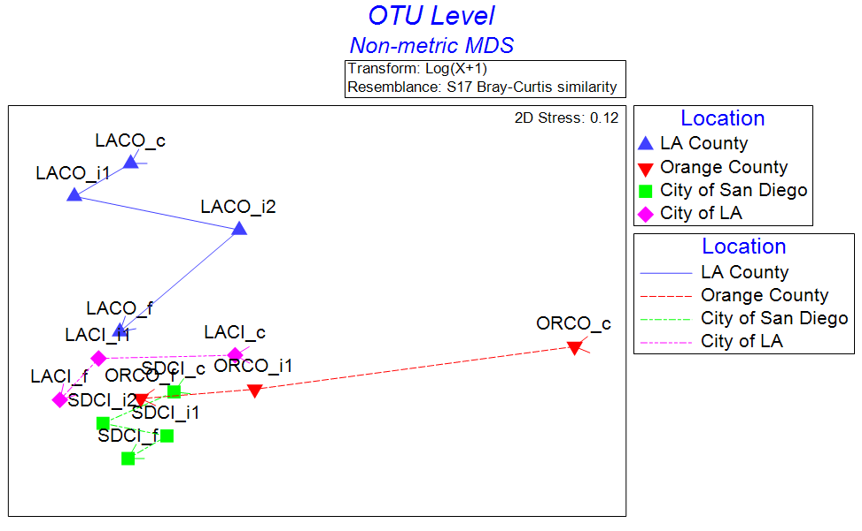

Table 4. Analysis of Similarity (ANOSIM, Primer v7) results showing pairwise differences in community structure between municipalities. The main effects test for overall differences between groups had a sample statistic (R): 0.431 (p<0.05). *Indicates significant differences between pairwise comparisons.

 | R | Significance | Possible | Actual | Number >=
Groups | Statistic | Level % | Permutations | Permutations | Observed
LA County, Orange County | 0.37 | 5.7 | 35 | 35 | 2
LA County, City of San Diego* | 0.729 | 2.9 | 35 | 35 | 1
LA County, City of LA | 0.611 | 5.7 | 35 | 35 | 2
Orange County, City San Diego* | 0.556 | 2.9 | 35 | 35 | 1
Orange County, City of LA | 0.111 | 40 | 10 | 10 | 4
City of San Diego, City of LA* | 0.722 | 2.9 | 35 | 35 | 1

4. Conclusion/discussion

Our results suggest that wastewater effluent can alter microbial communities in marine sediments by increasing diversity near outfalls, although these communities may differ depending on the effluent source. Community structure may converge toward a “baseline”, natural condition as effects of effluent are diminished with increasing distance from outfalls. Neither the physical location along the southern California coast (i.e., municipality) nor the depth of the sediment samples (56m-98m) were strongly associated with microbial community composition. Proximity to the outfall pipe was the dominant factor associated with community structure, as samples converged in similarity as distance from the outfalls increased (Fig 3). Some exceptions to the general patterns were observed. The microbial community in the Orange County “close” to the outfall pipe was most unique relative to the other stations. Although the MDS plot demonstrates a trend in the shift in the microbial community at the OTU level, it appears that the samples closest to the pipes were affected by geochemical changes independent of spatial variation.

Our results provide novel information on the effects of treated wastewater effluent on microbial communities that inhabit marine sediments. These results generally support other studies that have demonstrated similar responses in different environments or anthropogenic pressures. Saarenheimo et al., 2017, evaluated the microbial community in two sites at Boreal Lake sediments, reporting a significant shift in communities between the discharge/outfall site and the control stations. In addition, they noted a gradual shift towards the normal community located downstream from the outfall. In other studies, microbial community changes have been observed in response to land-based influences such as paper mills (Guo et al., 2016), wastewater outfall along coral reefs (Staley et al., 2017), wastewater effluent discharge in Australian stream sediments (Wakelin et al., 2008) and along a nitrogen pollution gradient (Xiong et al., 2014).

Overall, the most abundant bacteria were phyla Firmicutes followed by phyla Proteobacteria. When examining the top abundant bacteria, phyla Firmicutes was the dominant bacteria across all municipalities and distance-from-the-pipe, except for Orange County (Fig 2). In contrast, the most abundant phyla at the Orange County “close” were Proteobacteria, Actinobacteria, Planctomycetes, Bacteroidetes and Chloroflexi. For reasons unknown, this community was altered resulting in shifts and a declined percent abundance (Supplement X) at that station, however the “close” stations at the remaining three wastewater-treatment plants did not appear to be as affected. The data were normalized and therefore the sequence reads would not have influenced the data outcome. Noteworthy is that at all stations the most abundant Firmicutes (39-70%) was, in contrast, at very low abundance (7%) at ORCOc suggesting the outfall contributed factors that inhibited productivity and reproducibility of the Firmicutes phyla at that location.

Chu et al (2018) reported Proteobacteria and Bacteroidetes as the most abundant phyla in effluents and sediments collected from the wastewater-treatment plant outfall in Lake Michigan and the abundance of these two phyla decreased in sediment samples with increasing distance from the treatment plants. Proteobacteria were found to be the dominant phylum at wastewater-treatment outfalls in China (Liu and Zheng, 2016; Zhang et al., 2016; Zhang et al., 2014) Canada, USA and Singapore (Zhang et al., 2012). Bacteroidetes was high in abundance at outfall stations in southeast Florida (Campbell et al., 2015) and was the second most abundant phyla in activated sludge from eight wastewater-treatment plants in China (Liu and Zheng, 2016). Fecal-polluted sites were dominated by Proteobacteria, Firmicutes, Actinobacteria, Bacteroides and Spirochaetes in an urban Santa Ana River watershed in southern California (Ibekwe et al., 2016) with Proteobacteria being the dominant phylum. Vierheilig et al., 2015, noted that fecal communities collected from a broad range of animals were dominated by Firmicutes, Bacteroidetes and Proteobacteria.

Reportedly, Actinobacteria are widely distributed in marine habitats (Stach et al, 2003), however this phylum was most abundant (11.9%) at the closest outflow station for the Orange County treatment plant when compared to the other treatment-plant stations (1.7-5.8%). Chen et al (2016) noted the Actinobacteria were significantly correlated to pH, total organic carbon and other geochemical factors rather than to spatial distributions in deep-sea sediments from the Southwest Indian Ridge. These findings may corroborate and support the evidence of the Actinobacteria being the fourth to fifth most abundant phyla at the wastewater outfall stations in this study.

Bacteroidetes was most abundant at ORCO_{c} (11.6%) compared to the remaining sample stations (1.5-4%) and was the second most abundant phyla from eight wastewater-treatment plants with activated sludge (Liu and Zheng, 2016). Within the phylum Bacteroidetes is the genus Bacteroides, the most fecal abundant bacteria (Moore and Holdeman, 1974; Sghir et al., 2000). At ORCO_{c}, ORCO_{i1} and LACO_{i2} the genus Bacteroidetes ranged from 2-7% but was negligible (<1%) at the remaining stations. The gastrointestinal tract of humans and animals contains Bacteroidetes (Campbell et al., 2015; Qin et al., 2010) and this phylum have been known to occur in a variety of habitats such as soils, oceans and freshwaters (Thomas et al., 2011). The phyla Firmicutes and Bacteroidetes comprise >98% of the 16S rRNA gene sequences isolated from the intestinal fauna of mammals (Thomas et al., 2011; Ley et al., 2006), thus supporting our findings at the California wastewater treatment outfall stations.

To our knowledge, this study is the first description of the effects of wastewater effluent on microbial community structure in marine sediments and provides a starting point for future comparisons using next-generation sequencing technology. A more frequent sampling regime along with multiple seasons may provide a more complete picture of the shifts or resiliency of the microbial population along the outfall gradient. In summary, methods used in this study provided a useful approach to demonstrate a shift in these sediment communities.

Disclosures: Conflicts of interest: none. All authors have approved the final article.

EPA disclosure statement?

ACKNOWLEDGEMENTS: Erik Pilgrim, EPA for the sediment samples, David Gillett at SSCWRP for municipality information, Anne for GIS analysis distance calculations;

REFERENCES

Apprill A, McNally S, Parsons R, Weber L. 2015. Minor revision to V4 region of SSU rRNA 806R gene primer greatly increases detection of SAR11 bacterioplankton. Aquatic Microbial Ecology. 75:129-137.

Campbell, A.M., J. Fleisher, C. Dinigalliano, J.R White and J.V. Lopez. 2015. Dynamics of marine bacterial community diversity of the coastal waters of the reefs, inlets, and wastewater outfalls of southeast Florida. Microbiol Open, 4(3):390-408.

Caporaso JG., Lauber CL., Walters WA., Berg-Lyons D., Lozupone CA, Turnbaugh PJ, Fierer N., and Knight R. 2011. Global patterns of 16S rRNA diversity at a depth of millions of sequences per sample. PNAS. 108(1):4516-4522. DID I CITE THIS?

Caporaso JG, Lauber CL, Walters WA, Berg-Lyons D, Huntley J, Fierer N, Owens SM, Betley J, Fraser L, Bauer M, Gormley N, Gilbert JA, Smith G, Knight R. 2012. Ultra-high-throughput microbial community analysis on the Illumina HiSeq and MiSeq platforms. ISME Journal 6:1621-1624.

Chu, B.T.T., Petrovich, M.L., Chaudhary, A., Wright, D., Murphy, B., Wells, G., and Poretsky, R. 2018. Metagenomics reveals the impact of wastewater treatment plants on the dispersal of microorganisms and genes in aquatic sediments. Appl Environ Microbiol. 84(5):e02168-17

Fisher, R.A., Corbet, A.S. & Williams, C.B. 1943. The relation between the number of species and the number of individuals in a random sample of an animal population. Journal of Animal Ecology 12, 42–58.

Fouhy, F., Clooney, A.G., Stanton, C., Claesson, M.J., and Cotter, P.D. 2016. 16S rRNA gene sequencing of mock microbial populations- impact of DNA extraction method, primer choice and sequencing platform. BMC Microbiol, 16:123-135.

Guo, J., Zhao, L., Lu, W., Jia, H., and Sun, Y. 2016. Bacterial communities in water and sediment shaped by paper mill pollution and indicated bacterial taxa in sediment in Daling River. Ecol Indicators 60:766-773.

Huse, S.M., D.B Mark Welch, A. Voorhis, A. Shipunova, H.G, Morrison, A.M. Eren, and M.L. Sogin. 2014. VAMPS: a website for visualization and analysis of microbial population structures. BMC Bioinformatics 15:41. DO I NEED THIS?

Ibekwe, A.M., J. Ma and S.E. Murinda. 2016. Bacterial community composition and structure in an urban river impacted by different pollution sources. Sci Total Environ (566-567):1176-1185.

James E. M. Stach, Luis A. Maldonado, Alan C. Ward, Michael Goodfellow and Alan T. Bull. 2003. New primers for the class Actinobacteria: application to marine and terrestrial environments. Environmental Microbiol 5(10): 828–84.

Klindworth, A., Pruesse, E., Schweer, T., Peplies, J., Quast, C., Hom, M., and Glockner, F.O. 2013. Evaluation of general 16S ribosomal RNA gene PCR primers for classical and next-generation sequencing-based diversity studies. Nucleic Acids Res 41(1).

Ley, R. E., Turnbaugh, P. J., Klein, S., and Gordon, J. I. 2006. Microbial ecology: human gut microbes associated with obesity. Nature 444, 1022–1023.

Lyon, G.S. and M.A. Sutula. 2011. Effluent discharges to the Southern California Bight from large municipal wastewater treatment facilities from 2005 to 2009 [Internet]. SCCWRP Annual Report 2011. Costa Mesa (CA): Southern California
Coastal Water Research Project. Available from http://ftp.sccwrp.org/pub/download/
DOCUMENTS/AnnualReports/2011AnnualReport/ar11_223_
236.pdf

Moore, W. E., and Holdeman, L. V. 1974. Special problems associated with the isolation and identification of intestinal bacteria in fecal flora studies. Am. J. Clin. Nutr. 27, 1450–1455.

Ping Chen, Limin Zhang, Xiaoxuan Guo, Xin Dai, Li Liu, Lijun Zi, Jian Wang, Lei Song, Yuezhu Wang, Yaxin Zhu, Li Huang and Ying Huang. 2016. Diversity, Biogeography, and Biodegradation Potential of Actinobacteria in the Deep-Sea Sediments along the Southwest Indian Ridge. Front. Microbiol., 29 August 2016. NEED PAGE, VOLUME

Qin et al., 2010 (in Campbell paper)

R Core Team (2017). R: A languae and environment for statistical computing, v3.4.3. R Foundation for Statistical Computing, Vienna, Austria. URL https://www.R-project.org/

Rosen, G.L., E.R. Reichenberger and A.M. Rosenfield. 2011. NBC: The Naïve classification tool webserver for taxonomic classification of metagenomic reads. Bioinformatics 27 (1):127-129. DID I USE THIS?

Saarenheimo, J., Aalton, S.L., Rissanen, A.J., and Tiirola, M. 2017. Microbial community response on wastewater discharge in Boreal Lake sediments. Front Microbiol 8:750.

Sghir, A., Gramet, G., Suau, A., Rochet, V., Pochart, P., and Dore, J. 2000. Quantification of bacterial groups within human fecal flora by oligonucleotide probe hybridization. Appl. Environ. Microbiol. 66, 2263–2266.

Sogin, M.L., H.G. Morrison, J.A. Huber, D.M. Welch, S.M. Huse, R.R. Neal, J.M. Arrieta, G.J. Herndl. 2006. Microbial diversity in the deep sea and the underexplored “rare biosphere.” Proc Natl Acad Sci USA, 103:12115-12120.

Stackebrandt, E., Goebel, B.M., 1994. A Place for DNA-DNA Reassociation and 16S
rRNA sequence analysis in the present species definition in bacteriology.
International J Systematic Bacteriology 44(4), 846.

Staley, C., Kaiser, T., Gidley, M.L., Enochs, I.C., Jones, P.R., Goodwin, K.D., Sinigalliano, C.D., Sadowsky, M.J., and Cuan, C.L. 2017. A next-generation sequencing approach to characterize the impacts of land-based sources of pollution on the microbiota of Southeast Florida coral reefs. Appl Environ. Microbiol. 83(10):8-16.
https:// doi.org/10.1128/AEM.03378-16

Thomas, F., Hehemann, J.H., Rebuffet, E., Czjzek., M., and Michel, G. 2011. Environmental and gut Bacteroidetes: The food connection. Frontiers in Microbiol 2(93):1-16.

Vierheilig, J., Savio, D., Ley, R.E., Mach, R.L., Farnleitner, A.H., and Reischer, G.H. 2015. Potential applications of next generation DNA sequencing of 16S rRNA gene amplicons in microbial water quality monitoring. Water Sci Technol. 72(11):1962-1972.

Wakelin. S.A., Colloff, M.J., and Kookana, R.S. 2008. Effect of wastewater treatment plant effluent on microbial function and community structure in the sediment of a freshwater stream with variable seasonal flow. Appl Environ Microbiol 74(9):2659-2668.

Wang, Z.H., J.Q. Yang, D.J. Zhang, J. Zhou, C.D. Zhang, X.R. Su and T.W. Li. 2014. Composition and structure of microbial communities associated with different domestic sewage outfalls. Genetics Molecular Res, 13(3):7542-7552.

Yan Zhang, Lujun Chen, Renhua Sun, Tianjiao Dai, Jinping Tian, Rui Liu and Donghui Wen. Effect of wastewater disposal on the bacterial and archaeal community of sea sediment in an industrial area in China. 2014. FEMS Microbiol Ecol 2014) PAGE, VOLUME?

Yan Zhang, Lujun Chen, Renhua Sun, Tianjiao Dai, Jinping Tian , Wei Zheng , Donghui Wen, 2016. Journal of Env Sciences 44:57-68.

Zhang, T., Shao M-F., and Ye, L. 2012. 454 Pyrosequencing reveals bacterial diversity of activated sludge from 14 sewage treatment plants. ISME J. 6:1137-1147.

Supplemental Material:

Percent abundance, Phylum, Family, Genera

Table 1. Site locations for sediment collection. Each station was grouped by nearest governing municipality and further grouped by relative location from the outflow pipe of the nearest wastewater-treatment plant.

Waste-Water Treatment Plant | Abbreviation | Station ID | Station Depth (m) | Distance from  outfall pipe | Distance from  outfall pipe (m) | Latitude, longitude
City of Los Angeles | LACI_{c} | Z2 | 59 | close | 0 | 33.9075; -118.52445
 | LACI_{i1} | NA2 | 57 | intermediate₁ | 1256.5 | 33.9009; -118.515116
 | LACI_{f} | FA11 | 56 | far | 2918.7 | 33.89323; -118.50175
City of San Diego | SDCI_{c} | E17 | 98 | close | 0 | 32.6746667; -117.32567
 | SDCI_{i1} | E14 | 98 | intermediate₁ | 1106.1 | 32.6656667; -117.32483
 | SDCI_{i2} | E20 | 98 | intermediate₂ | 1005.4 | 32.6826667; -117.32783
 | SDCI_{f} | E26 | 98 | far | 7048 | 32.730333; -117.34283
Orange County | ORCO_{c} | 0 | 59 | close | 0 | 33.57762; -118.01613
 | ORCO_{i1} | 1 | 56 | intermediate₁ | 656.3 | 33.57622; -118.00997
 | ORCO_{f} | CON | 56 | far | 8082.7 | 33.60062; -118.08978
Los Angeles County | LACO_{c} | 8C | 61 | close | 0 | 33.6985; -118.336
 | LACO_{i1} | 6C | 61 | intermediate₁ | 2176.4 | 33.7078; -118.354
 | LACO_{i2} | 3C | 61 | intermediate₂ | 7906.6 | 33.73; -118.403
 | LACO_{f} | 0C | 61 | far | 16565 | 33.8072; -118.431

